January 1, 2023

Power BI:

Power BI Is an industry leading Microsoft BI tool that essentially functions to provide insights into your data insights that can then be used to shape your business decision making. The BI and Power BI I stands for Business Intelligence Power bi I takes data, you provide, analyzes it and organizes it into shareable visual reports and models that track metric trends, relationships, potential outcomes and much more.

The Power BI Main Components:

Power BI is made up of three main components:

* The Report View
* The Data View
* The Model View

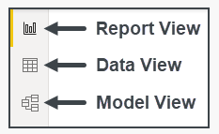

The data view displays tables of acquired data form sources like:

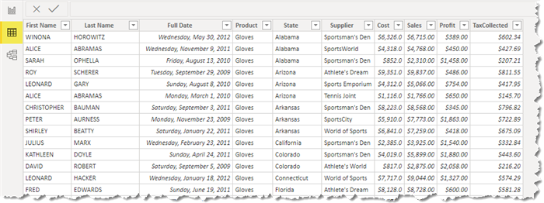

The model view displays the tables from the data view in a bird’s eye view shown relationships connectors between the tables.

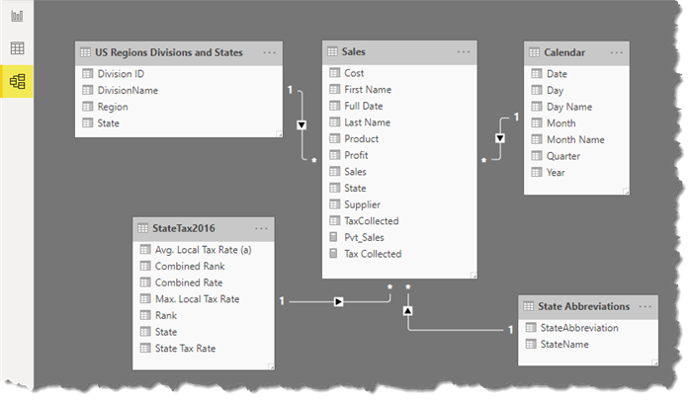

The Report view is where all visualizations are presented

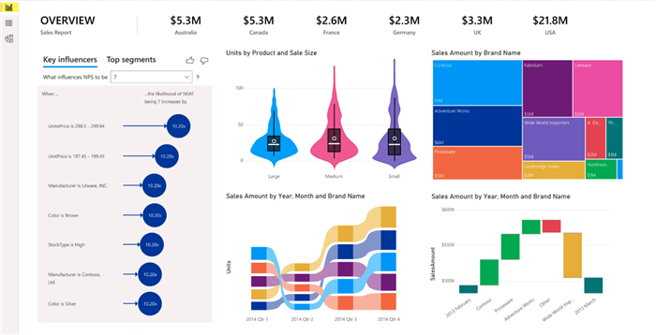

These visualizations can be tables, charts, graphs, slicers, KPIs, bookmarks, etc.

Acquired Data:

The first step in any report is to acquire the data that will drive the report visualizations.

This data can come from a variety of sources:

* Delimited Text Files
* Excel Spreadsheets
* Databases
* Websites
* PDF Files
* Folders
* Online Services

The list of connectors is quite extensive and growing every month with regularly scheduled updates.

Clicking on Get Data provides a list of connectors.

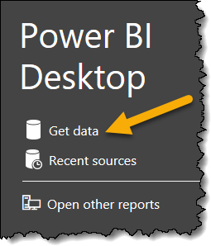

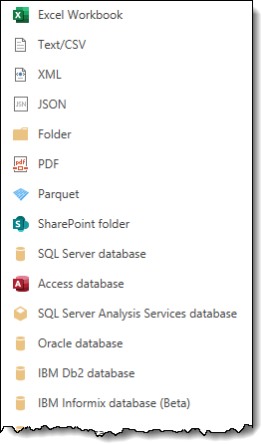

Data view:

Power BI desktop application gives full access to all features for creating reports.

Transform data, model data and visualize data in one application.

Data Analysis Expressions (DAX):

Data Analysis Expressions is a library of functions and operations that can be combined to build formulas and expressions.

From the Table Tools tab, we can

* Create new measures, columns, and tables with DAX expressions, or formulas
* Edit the table and manage relationships

When working in the column tool tab, the Data Category field allows us to select the category type for the data in the column so that Power BI treats it accordingly for visualizations.

Clean and Transform data with Power Query:

Microsoft’s engine for data preparation and transformation is called **Power Query**. Power Query extracts the data and performs the importation from the data source then Power Query editor applies necessary transformations.

The function of Power Query:

* Connects to and cleans a wide variety of data types.
* Stores reshaped data in many locations.
* Applies queries – data transformations from the original extraction of data.

Access the Power Query Editor:

The power query editor allows you to transform, edit, and select data before loading it into Power BI. Select the "Home" tab. In the query's group, click the "Transform data" drop-down. Select "Transform data".

The Power Query Editor allows us to select, edit and transform data before loading it into Power BI.

Applied Steps List in Power Query Editor:

The Applied Steps List functionality is valuable because it lets us see how the data shaped and cleaned.

We can create a new query based on the applied steps by selecting extract previous. When we use extract previous, the new query will have all steps that occurred before the step we selected.

Power Query Editor will always record transformations as steps in the Applied Steps List. As a result, our source data will not be altered.

Creating Dashboard:

First click on get the data from other source and choose the file option and choose excel and text because we have these two format files. When we choose our text file and click on transform data button then file will open on Power Query Editor. We use transform tab when we have to proper data. like we have sales column with whole number. It’s fine. If it has decimal or float then it should make it to whole number to perform correctly data to reports.

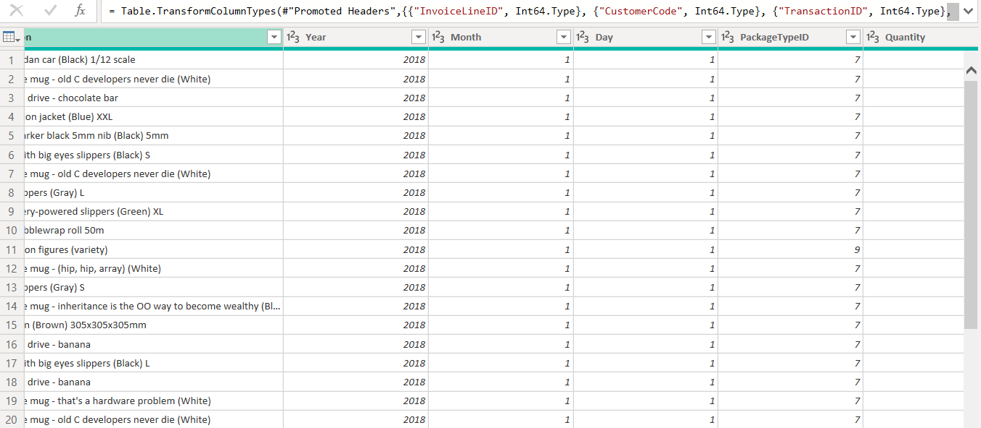

Now let’s select month first because regional settings of US regional settings then day and year. Right click and select merge columns. For the separator choose slash (/), call column name date and click ok.

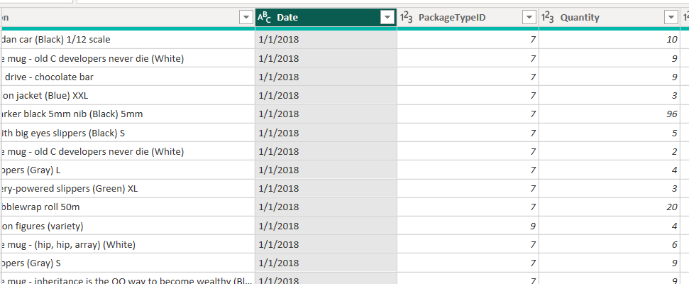

Here date column is now text data type and that’s not right and change it to date data type by right click and choose date.

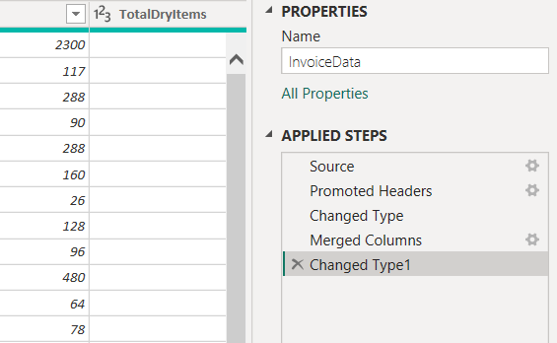

All of our steps are registered in applied steps. So, every time we upload a new file with the latest data, all these steps are automatically going to be applied to that dataset.

Now open a new excel file from the ribbon, New Source under Home tab and choose customer master data from computer.

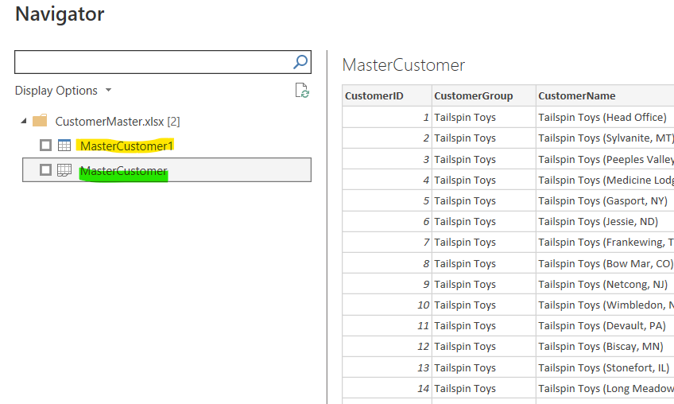

Now inside the file, we have a table (small blue top bar) and sheet. It’s always a good practice with a table. This way we can avoid numbers that might just show up on this sheet that we don’t want imported. Select first one table, click on okay.

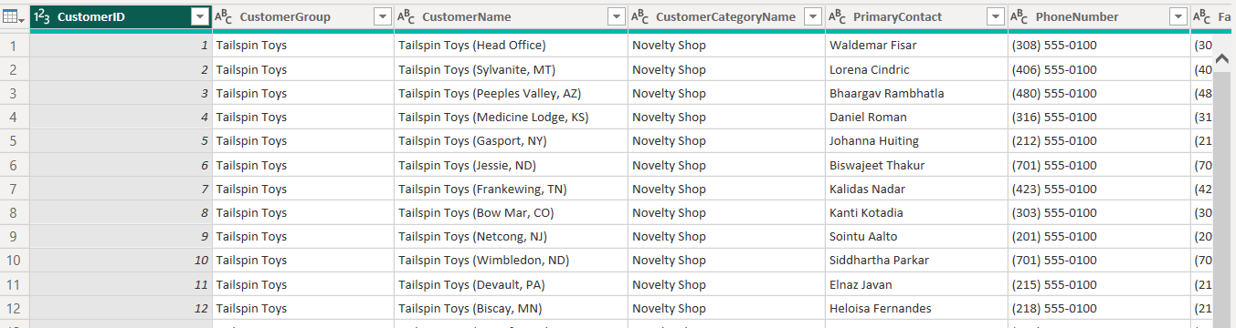

We have a lot of information about the customer here and we have city province. It would be great to split city and province into two separate columns. We can do that easily with power query. Right mouse click, split column, by delimiter

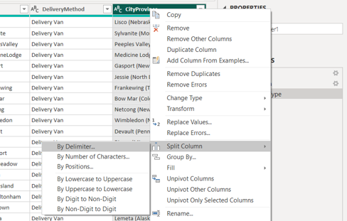

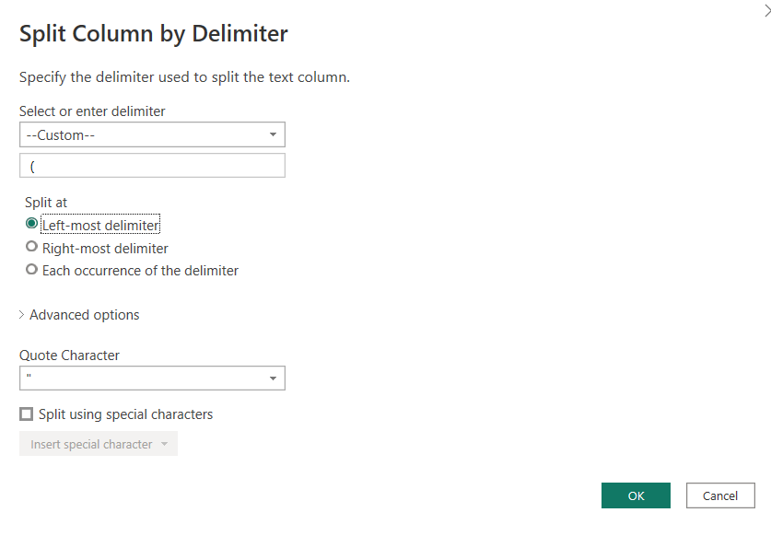

One space and ‘(‘this symbol.

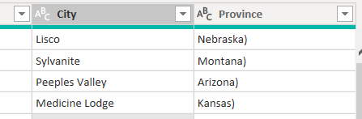

Now we have city and province in separated columns. Now delete extra ) bracket in province column. Right mouse click on province column and choose replace values and do as follows.

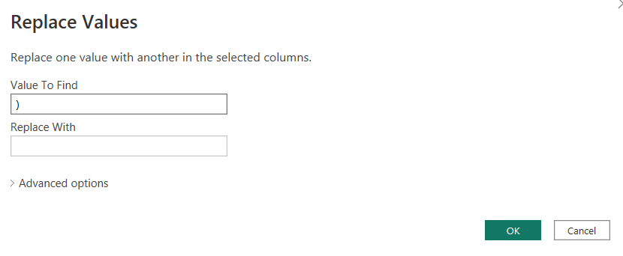

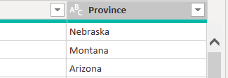

Now it’s in correct format.

Also rename the query name to master customer. Now delete unwanted columns. We are selecting customer id because it connects to with sales table.

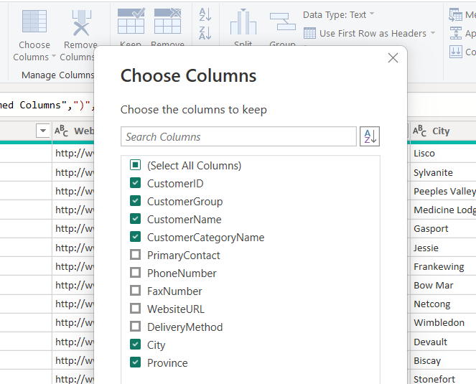

Unclick all unwanted columns from choose columns.

Now, close and apply. And it’s going to load the data into Power BI, into the data model.

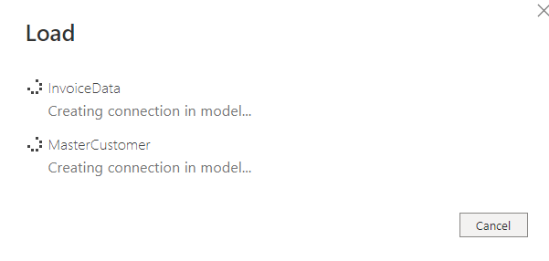

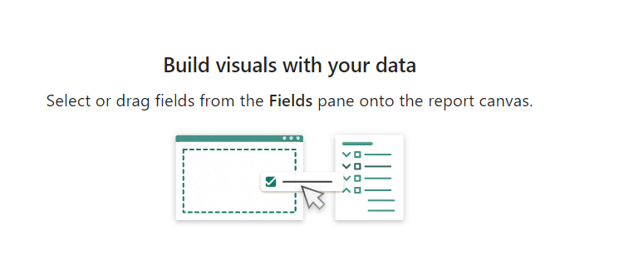

So now that the data is there, we’re ready to build the visuals.

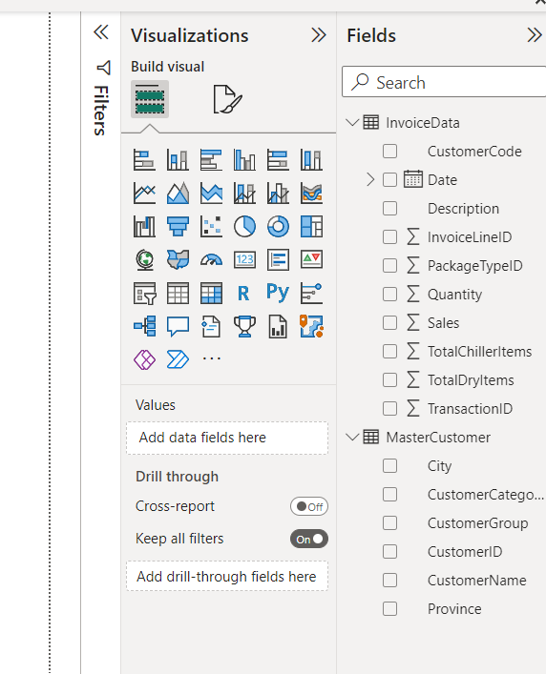

The connection between the InvoiceData and MasterCustomer is the CustomerCode and CustomerID. So, instead of merging tables to bring over all the other customer information that we need to the invoice data file, we are going to use relationships and connect these together.

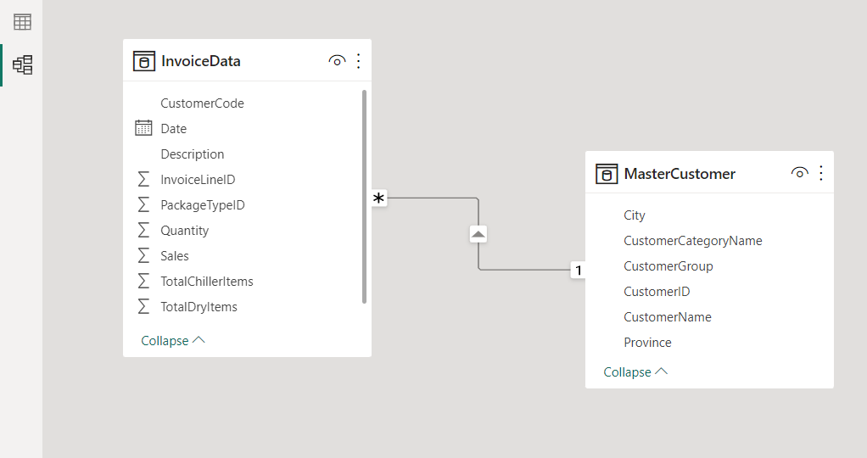

Power BI is automatically setup relationships. How did it know what to do? Well, Power BI is smart enough and it recognized that customer id and customer code seemed to be the same thing.

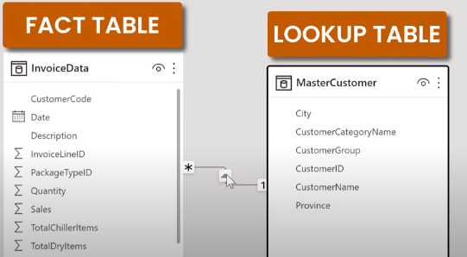

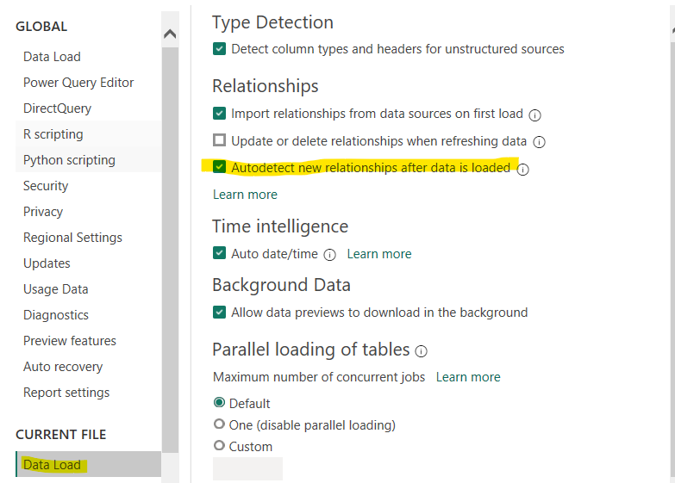

Because of this it did.

Let’s insert chart with Slicer:

Select the item what we want and create visualize with clustered bar chart.

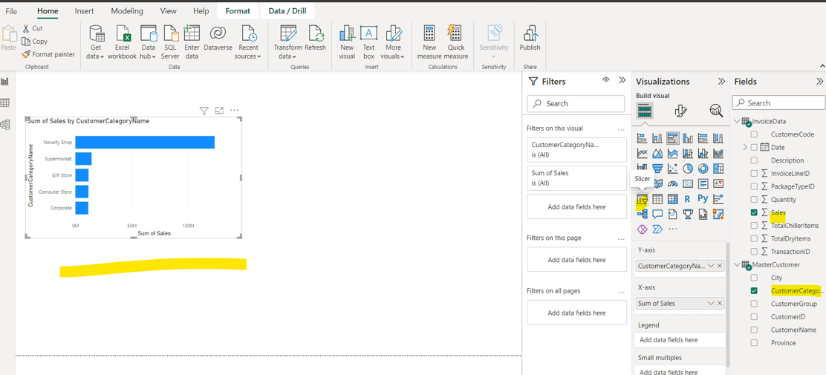

and select slicer visualization and choose year under Date.

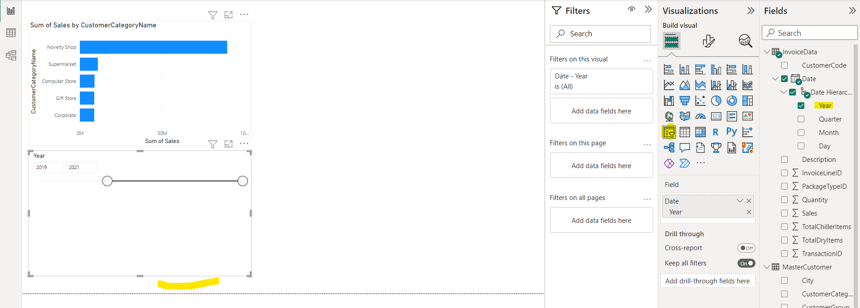

This is one way of looking at dates to notice. Whenever we’re updating this, the slicer visual updated as well. Let’s change that view. Select top right corner of slicer visualization and choose dropdown.

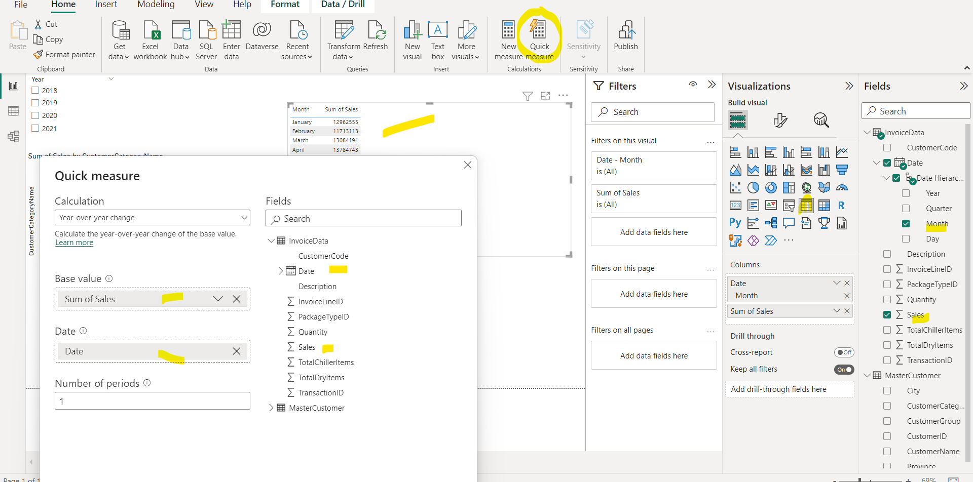

Click ok. And formula got automatically added by Power BI.

